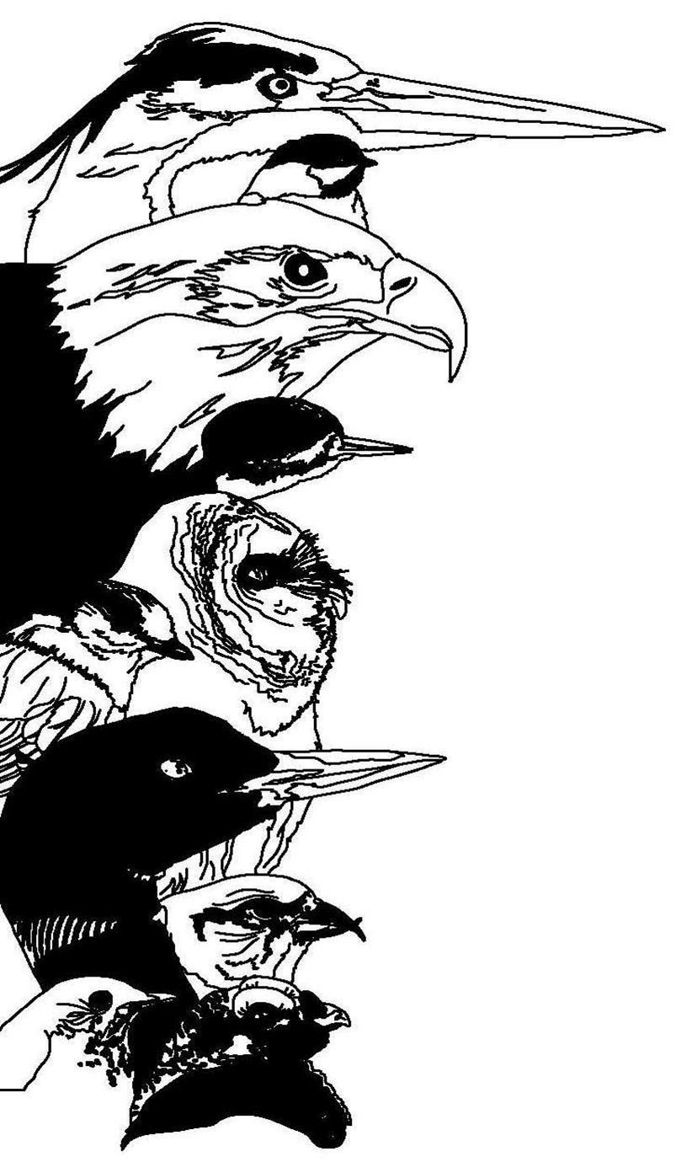
Registration Form for those paying by credit card.
An additional 4% fee will be charged.
MasterCard and Visa only.
To pay by check, please use alternate registration form.

13th Great Adirondack Birding Celebration
5 - 7 June 2015

Mail completed form, with credit card information to:
Paul Smith's College VIC
8023 State Route 30
Paul Smiths
New York, 12970

Name: _____________________________________________________  Address: ___________________________________________________  State: __________________ Country: ___________ ZIP: ___________  Phone: ____________________________________________________  Email: _____________________________________________________  Credit Card Number: __________________________________________  CC Expiration Date: ________________ MasterCard ____ Visa _____ | Full registration participants: Check any of the events you plan to attend (not included in the registration fee):  ___ Friday - Birding Across the Adirondacks Field Trip, $72.80 additional fee (includes transportation and lunch)  ___ Friday – Birding the Saint Lawrence Valley, $72.80 additional fee (includes transportation and lunch)  Check any of the events you plan to attend (INCLUDED in registration fee):  ___ Friday Evening Lecture  ___ Saturday Catered Lunch (Vegetarian available)  ___ Saturday Evening Lecture and Reception
FOR OUR INFORMATION:
Have you attended a previous GABC? __ Yes __ No How many? _________
Approximate year of your most recent GABC? _____________________
How did you hear about this festival? ________________________________________________
_____________________________________________________________________________
Questions: Brian McAllister, 518-327-6241, bmcallister@paulsmiths.edu

NOTE: If you cancel by 22 May, you will receive a refund, minus a $25 handling fee. Those cancelling between 23 May and 1 June will receive a 50% refund. No refunds for cancellations after 1 June.
With a full registration, please choose one field trip per day. A la carte participants, please indicate which trips and days you wish to sign up for.
Saturday Field trips | First Choice | Second Choice | Sunday Field Trips | First Choice | Second Choice
Beginner Birder Workshop | ________ | ________ | Beginner Birder Workshop | ________ | ________
Birding by Ear | ________ | ________ | Birding by ear | ________ | ________
Bloomingdale Bog | ________ | ________ | Bloomingdale Bog | ________ | ________
Intervale Lowlands | ________ | ________ | Intervale Lowlands | ________ | ________
Madawaska Flow | ________ | ________ | Madawaska Flow | ________ | ________
Heaven Hill/John Brown Homestead | ________ | ________ | Heaven Hill/John Brown Homestead | ________ | ________
Whiteface Mountain | ________ | ________ | Whiteface Mountain | ________ | ________
Field trip meeting times and locations will be provided with your registration confirmation.

Fee Schedule: Full Registration (paying by credit card)
(check all that apply)
 | Friends of the VIC Member | Friends of the VIC Warbler | Northern New York Audubon Member | Nonmember
Three Day Registration (Friday through Sunday, includes all activities except Birding Across the Adirondacks Field Trip & Birding the Saint Lawrence Valley) – Early Bird (1 November 2014 – 8 May 2015) | __ $117.00 | __ $62.50 | __ $117.00 | __ $130.00
Three Day Registration (Friday through Sunday, includes all activities except Birding Across the Adirondacks Field Trip & Birding the Saint Lawrence Valley) – After 8 May 2015 | __ $131.04 | __ $72.80 | __ $131.04 | __ $145.60
Birding Across the Adirondacks Field Trip (Friday, not included in GABC registration) | __ $72.80 | __ $72.80 | __ $72.80 | __ $72.80
Birding the Saint Lawrence Valley (Friday, not included in GABC registration) | __ $72.80 | __ $72.80 | __ $72.80 | __ $72.80
Total

Fee Schedule: a la Carte (paying by credit card)
(check all that apply)
 | Friends of the VIC Member | Friends of the VIC Warbler | Northern New York Audubon Member | Nonmember
Beginner Birder Workshop and Field Trip | __ $36.40 | __ $20.80 | __ $36.40 | __ $41.60
Birding by Ear Workshop and Field Trip | __ $36.40 | __ $20.80 | __ $36.40 | __ $41.60
Bloomingdale Bog Field Trip | __ $36.40 | __ $20.80 | __ $36.40 | __ $41.60
Intervale Lowlands Field Trip | __ $36.40 | __ $20.80 | __ $36.40 | __ $41.60
Madawaska Flow Field Trip | __ $36.40 | __ $20.80 | __ $36.40 | __ $41.60
Heaven Hill/John Brown Homestead Field Trip | __ $26.00 | __ $15.60 | __ $26.00 | __ $31.20
Whiteface Mountain Field Trip* | __ $46.80 | __ $26.00 | __ $46.80 | __ $52.00
Birding Across the Adirondacks Field Trip (Friday) | __ $83.20 | __ $83.20 | __ $83.20 | __ $83.20
Birding the Saint Lawrence Valley (Friday) | __ $83.20 | __ $83.20 | __ $83.20 | __ $83.20
Total
* Includes toll road fee

A la Carte Participants:

- If you wish to participate in any field trips (including the all-day Friday field trips), you must register and pay by 30 May 2015 to be sure of a spot.
- If you wish to participate in the Thursday “Start Your Bird List at the VIC” walk ($20 for nonmembers), please pre-register by calling the VIC (518-327-6241) by 5:00 PM the day before. You may pay at the VIC front desk at the time of the walk.
- The Friday evening lecture, Saturday afternoon workshops, and Saturday evening lectures do not require pre-registration. The fee is collected at the VIC front desk.

