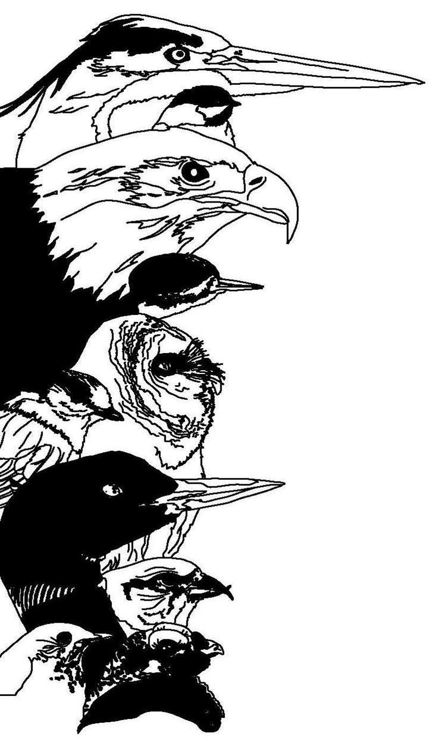
Registration Form for the

12th Great Adirondack Birding Celebration

Paul Smith's College VIC
Paul Smiths, NY 12970

6-8 June 2014
Name: _____________________________________________________  Address: ___________________________________________________  State: __________________ Country: ___________ ZIP: ___________  Phone: ____________________________________________________  Email: _____________________________________________________ |  | To register, mail completed form with check to:  Paul Smith's College VIC  8023 State Route 30  Paul Smiths  New York 12970  Make checks payable to Paul Smith's College VIC. Sorry, no credit cards.  For information: 518-327-6241
Check any of the events you plan to attend (not included in the registration fee):

___ Friday - Birding Across the Adirondacks Field Trip, $70 additional fee (includes transportation and lunch)
___ Friday - Essentials of Nature Photography Workshop, $70 additional fee

Check any of the events you plan to attend (INCLUDED in registration fee):
___ Friday Evening Lecture
___ Saturday Catered Lunch (Vegetarian available)
___ Saturday Evening Lecture and Reception

With a full registration, please choose one field trip per day:

Saturday Field trips | First Choice | Second Choice | Sunday Field Trips | First Choice | Second Choice
Beginner Birder Workshop | ________ | ________ | Beginner Birder Workshop | ________ | ________
Birding by Ear | ________ | ________ | Birding by ear | ________ | ________
Bloomingdale Bog | ________ | ________ | Bloomingdale Bog | ________ | ________
Intervale Lowlands | ________ | ________ | Intervale Lowlands | ________ | ________
Little Clear Pond (loons) | ________ | ________ | Little Clear Pond (loons) | ________ | ________
Madawaska Flow | ________ | ________ | Madawaska Flow | ________ | ________
Heaven Hill/Henry's Woods | ________ | ________ | Heaven Hill/Henry's Woods | ________ | ________
Whiteface Mountain | ________ | ________ | Whiteface Mountain | ________ | ________
Field trip meeting times and locations will be provided with your registration confirmation.

Registration Fees Per Person (check all that apply) |  |  | Fee Schedule
 | Three-day Registration (Friday through Sunday, includes all activities except Birding Across the Adirondacks Field Trip & Essentials of Nature Photography Workshop) |  | $125.00
 | Three-day Registration (Friends of the VIC member – 10% discount) |  | $112.50
 | Three-day Registration (Friends of the VIC Warbler – 50% discount) |  | $62.50
 | Three-day Registration (Northern New York Audubon member – 10% discount) |  | $112.50
 | Birding Across the Adirondacks Field Trip (Friday, not included in GABC registration) |  | $70.00
 | Essentials of Nature Photography Workshop (Friday, not included in GABC registration) |  | $70.00
 | Total Enclosed |  | _________________

